







UID /analytics/

ReadySetResource.com

Contents

14.1 - Dashboard 3

14.2 - Company Size Analytics 4

14.3 - User Interests Analytics 5

14.4 - Volume of Data per Company Over Time 6

14.5 - Community Analytics 7

14.6 - Contact Us Analytics 8

14.7 - Active Hours Analytics 9

14.8 - UID /analytics/ Work Log 10

# 14.1 - Dashboard

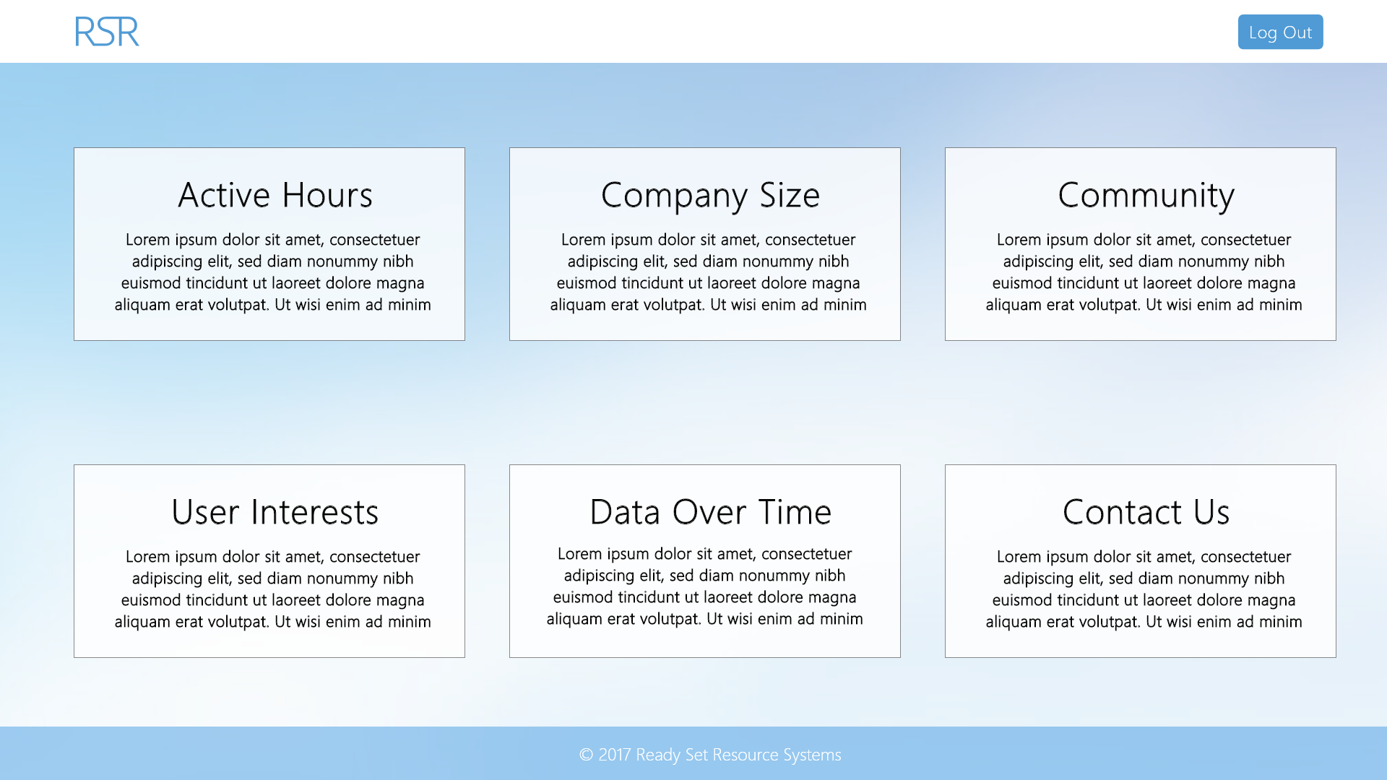

Input Permissible: None

Error Messages: None

# 14.2 - Company Size Analytics

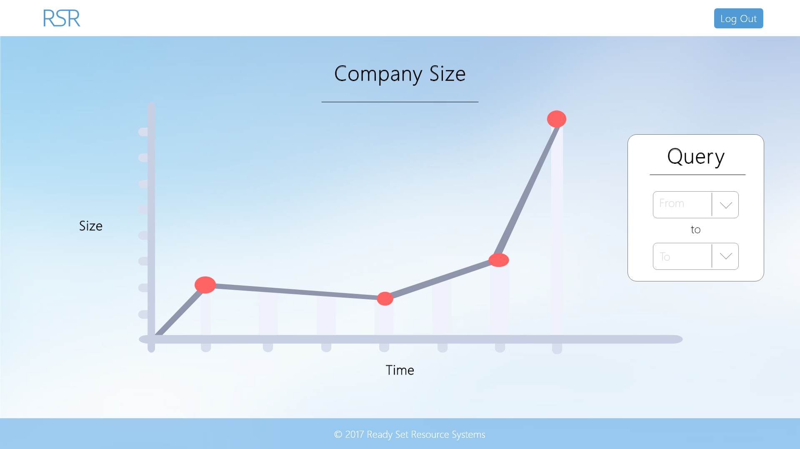

Input Permissible: - Date From

- Date To

Error Messages: - ‘Cannot select a date before start date’

# 14.3 - User Interests Analytics

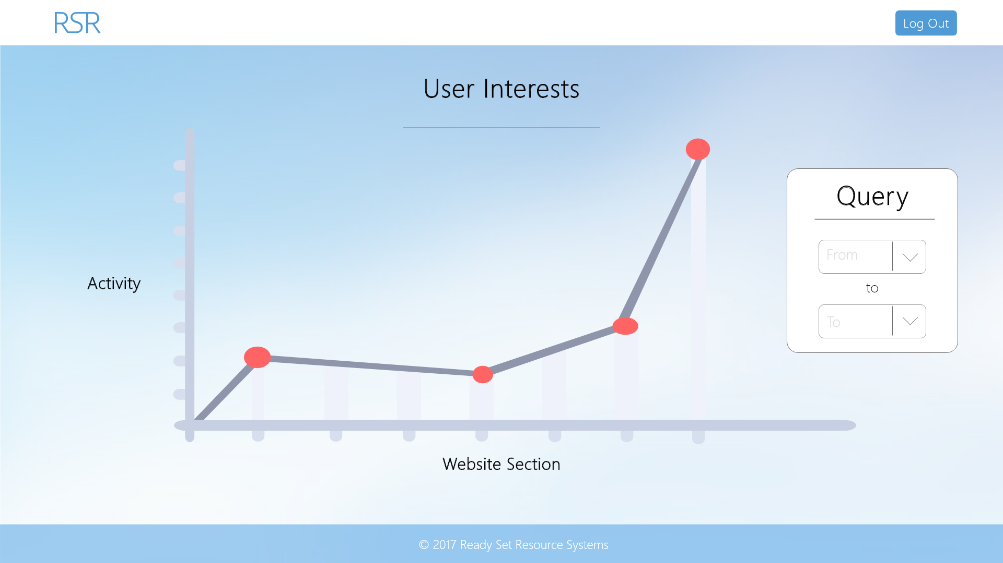

Input Permissible: - Date From

- Date To

Error Messages: - ‘Cannot select a date before start date’

# 14.4 - Volume of Data per Company Over Time

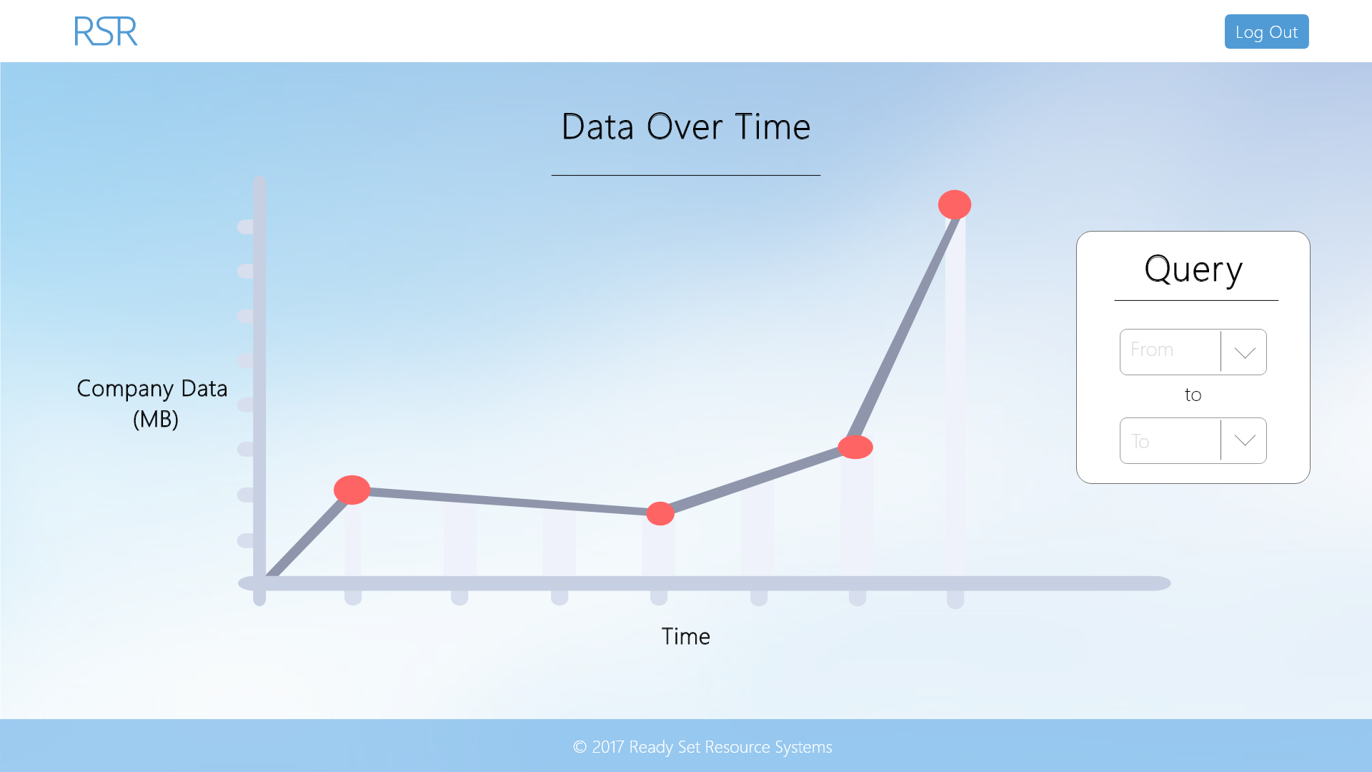

Input Permissible: - Date From

- Date To

Error Messages: - ‘Cannot select a date before start date’

# 14.5 - Community Analytics

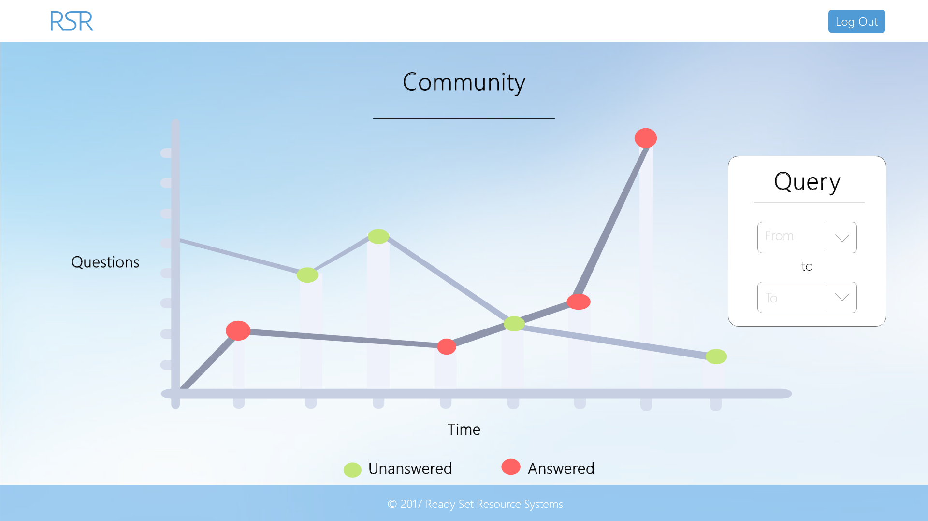

Input Permissible: - Date From

- Date To

Error Messages: - ‘Cannot select a date before start date’

# 14.6 - Contact Us Analytics

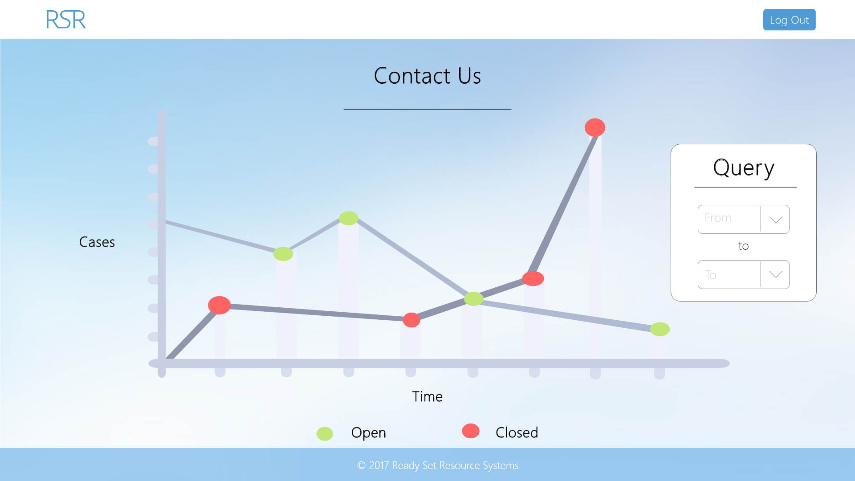

Input Permissible: - Date From

- Date To

Error Messages: - ‘Cannot select a date before start date’

# 14.7 - Active Hours Analytics

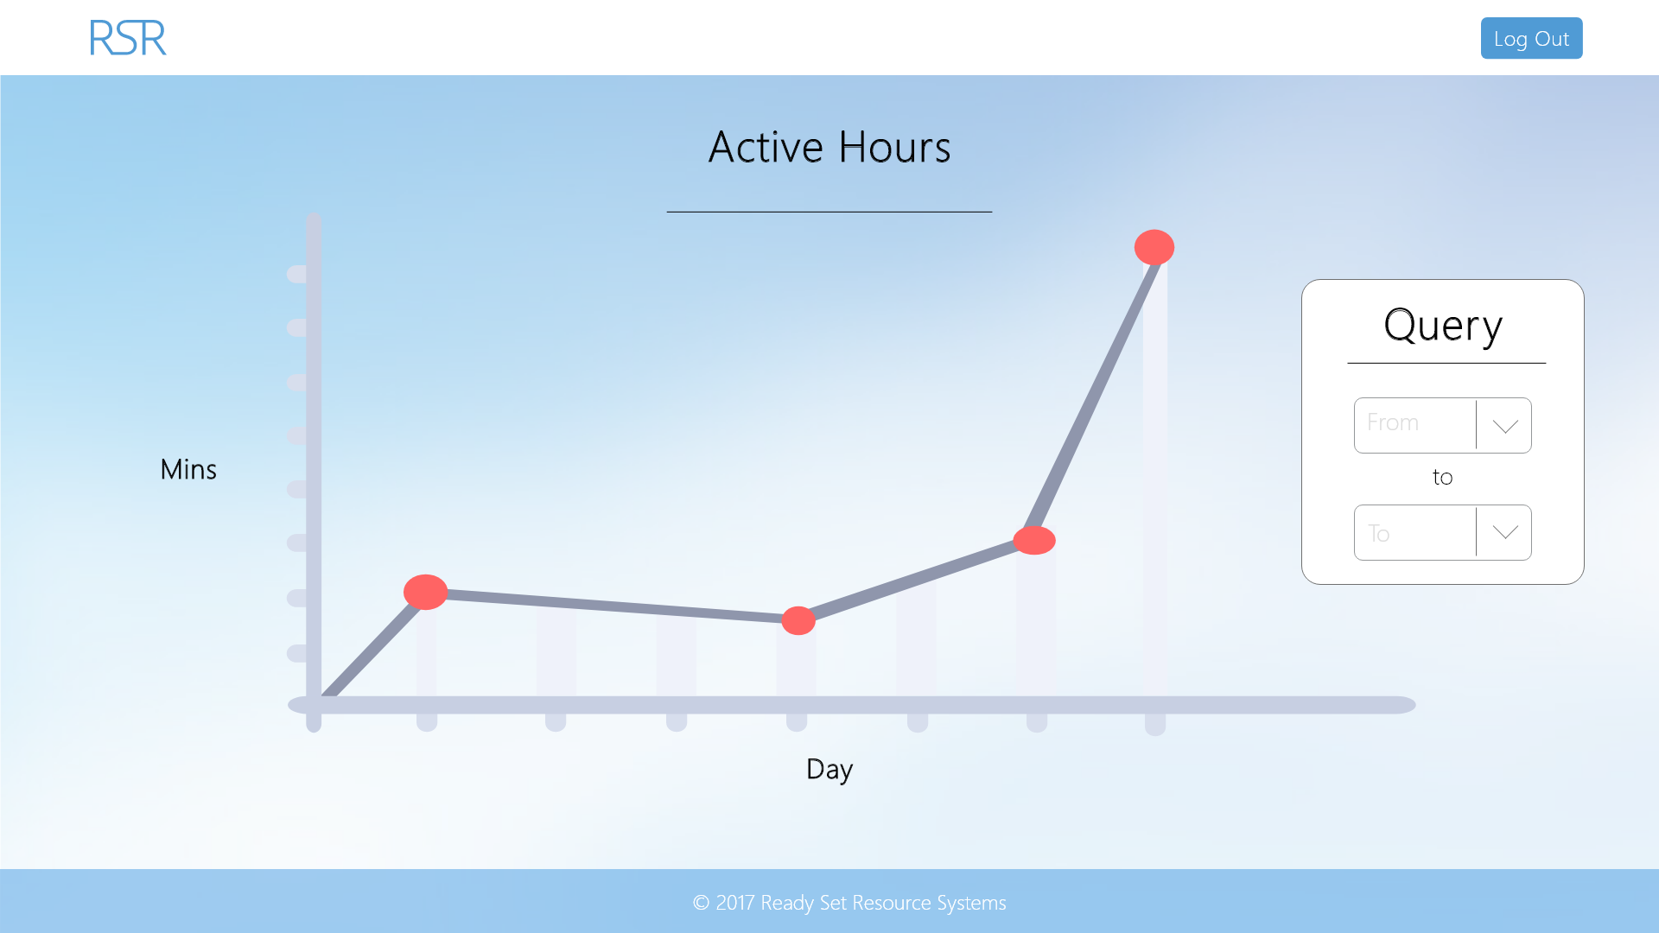

Input Permissible: - Date From

- Date To

Error Messages: - ‘Cannot select a date before start date’

# 14.8 - UID /analytics/ Work Log

| Entry | Description | Person | Date | Mins Spent |
| --- | --- | --- | --- | --- |
| 1 | Formatted the document | Aidan Marshall | 19/3/18 | 6 |
| 2 | Designed the website | Aidan Marshall | 19/3/18 | 94 |
| 3 | Added screenshots and page details | Aidan Marshall | 19/3/18 | 21 |
| 121 | | | | |